SCHOOL OF COMPUTING, ENGINEERING AND DIGITAL
TECHNOLOGIES



Al Tutor / Study Companion Chatbot

MSc Artificial Intelligence
Module Code: CIS4006-N
Student Full name- Rohit Raj Mahendrakar
Student ID-S3399337
Supervisor’s name- Alessandro Di Stefano
Wordcount: 2995

TABLE OF CONTENTS
1. Introduction 3
1.1 Purpose 3
1.2 Project 3
1.3 Target Job 3
1.4 Reflection Model 4
1. Activities 4
2.1 Project Planning and Scope Definition 4
2.2 Technical Architecture Design. 5
2.3 Task Assignment/Teamwork Management. 5
3.4 Recapturing and Reviewing Progress. 5
2.5 Integration and System Testing Co-ordination. 6
2.6 Communication and Conflict Management. 6
2.7 Documentation and Reporting 6
2. Contribution 6
3.1 Leadership and Strategic Direction 6
3.2 Technical Supervision and Integration Support. 7
3.3 Main Principles of Globalisation. 7
3.4 Quality and Ethical Oversight. 7
3.5 Outcome and Impact 8
3.6 Summary of Contribution 8
3. Reflection 9
4.1 Application of Driscoll’s Model 9
4.1.1 What? 9
4.1.2 So What? 9
4.1.3 Now What? 9
4.2 Challenges and Resolutions 9
4.2.1 Challenge 1: Balancing Technical and Managerial Responsibilities 9
4.2.2 Challenge 2: Team Communication Barriers 10
4.2.3 Challenge 3: Ethical and Performance Trade-offs 10
4.3 Reflection Summary 10
4. Personal Benefits 10
5.1 Skills in Strategic Management and Leadership. 10
5.2 The technical, analytical development. 11
5.3 Knowledge in Communication and Interpersonal Skills. 11
5.4 Ethical and Professional Awareness 11
5.5 Personal Development 11
5.6 Summary 11
5. Professional Values 11
6.1 Accountability 11
6.2 Integrity 12
6.3 Respect and Collaboration 12
6.4 Ethical Leadership in AI 12
6.5 Professional Value Reflection 13
7. References 13

Introduction

1.1 Purpose
This report is a reflective report on my internship experience as the Team Leader in an interdisciplinary project to develop a transparent AI tutoring system with an approach called the Retrieval-Augmented Generation (RAG) approach. Instead of being a technical report, this paper critically analyses my contribution, actions, and learning during the project with a specific focus on the leadership, making decisions, and developing professionally.

Since I was the Team Leader, my roles were not limited to the delegation of tasks. My role was to organise teamwork, track its progress, help with the communications between various technical positions, and make sure that the project complied with the academic goals and ethical standards. \

1.2 Project
The internship project entailed the design and implementation of an AI-based tutoring platform that aims to provide real-time responses to queries with good precision, explainability, and clarity. The driving force of the project was to touch on the issues of trust and explainability in the AI-based educational tools, especially when users can make use of generated answers without knowing how they were provided and what they can be trusted to offer.

As Team Leader, it was my duty to establish the general workflow, the milestones, and the proper cooperation of team members. I was also in charge of version control practices, documentation issues, and task assignments to facilitate accountability and traceability during the project life cycle.
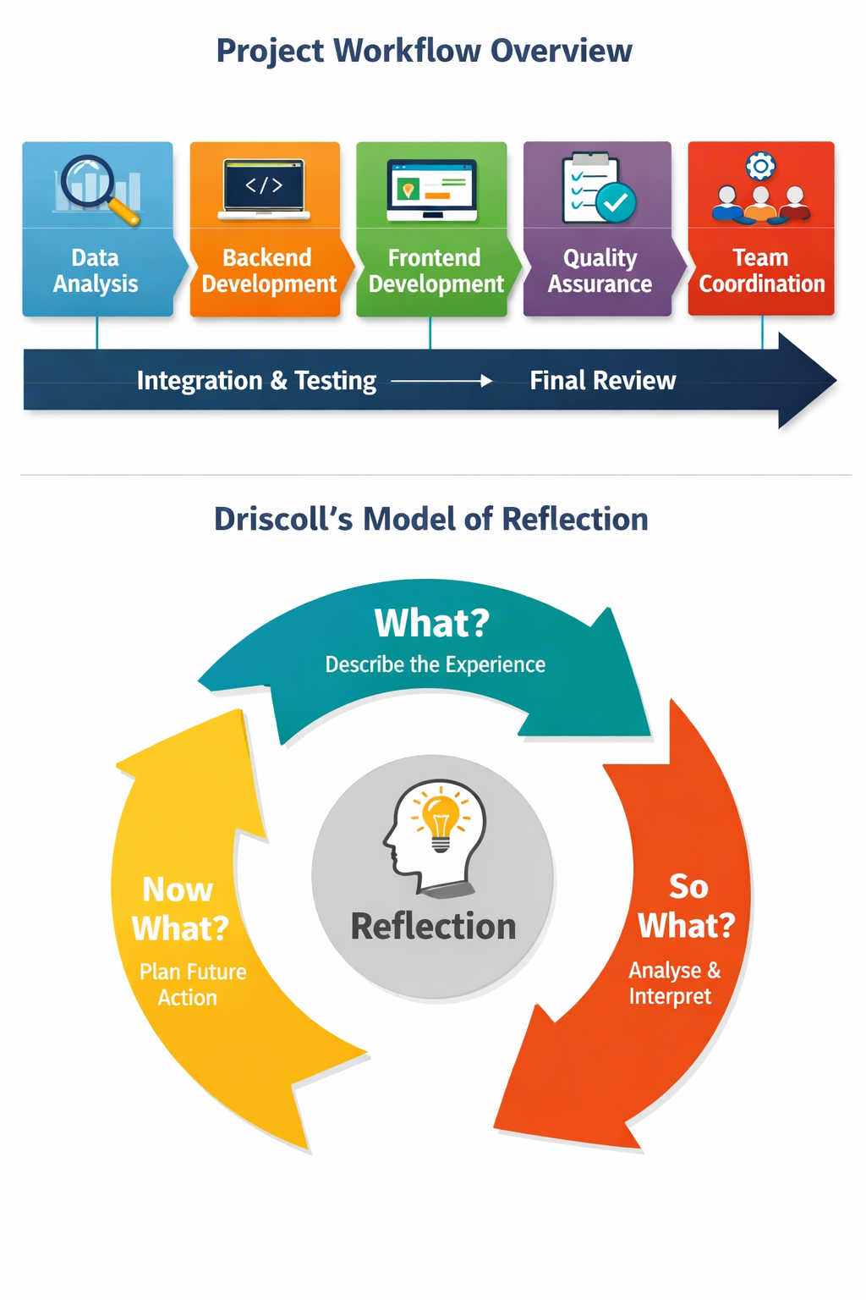

Figure 1. Project Workflow Overview Diagram.

1.3 Target Job
My long-term career goal is to advance to a position like Technical Project Manager or AI Systems Architect, where I will have an opportunity to integrate technical knowledge with leadership and impact, and strategy. The internship seemed to be quite consistent with that objective, as I was put in a situation where I had to handle both the people and the processes within a technically complex project. This facilitated my exposure to work under an agile-type development space, to organise the activities in an interdisciplinary team, and to communicate with both technical and non-technical stakeholders effectively.

1.4 Reflection Model
To aid the systematic and critical thought in the process of writing this report, I used the Model of Reflection developed by Driscoll, which is founded on the following questions: What? So What? and Now What?. This model gave a proper strategy through which I could look at my experiences and explain them in their relevance, and also where they can be improved in the future.

Figure 2. The Model of Reflection of Driscoll.

Activities

2.1 Project Planning and Scope Definition
The initial task I played as Team Leader was to set a clear project roadmap and the scope of work for each team member, depending on the experience and strength of the team members. To achieve my goals, I have designed an organised plan wherein I have set some objectives to be completed every week, where all the team members understand what is needed and what is expected after completion in each project stage. In sustaining this planning process, I came up with a milestone-based schedule that would attach tasks to definite deliverables and dependencies.

2.2 Technical Architecture Design.
This was one of my most important activities that led to the overall structure of the system at a conceptual level. Although I did not apply the technical components, I collaborated closely with other members of the group, and thus, the system design was made modular, coherent, and in line with the transparency objectives of the project.

I also negotiated that a layered architectural strategy was the one to follow, which successfully served in the separation of responsibilities but in the integration of components. They facilitated the development as an independent unit and minimised the risks of integration in the future of the project.
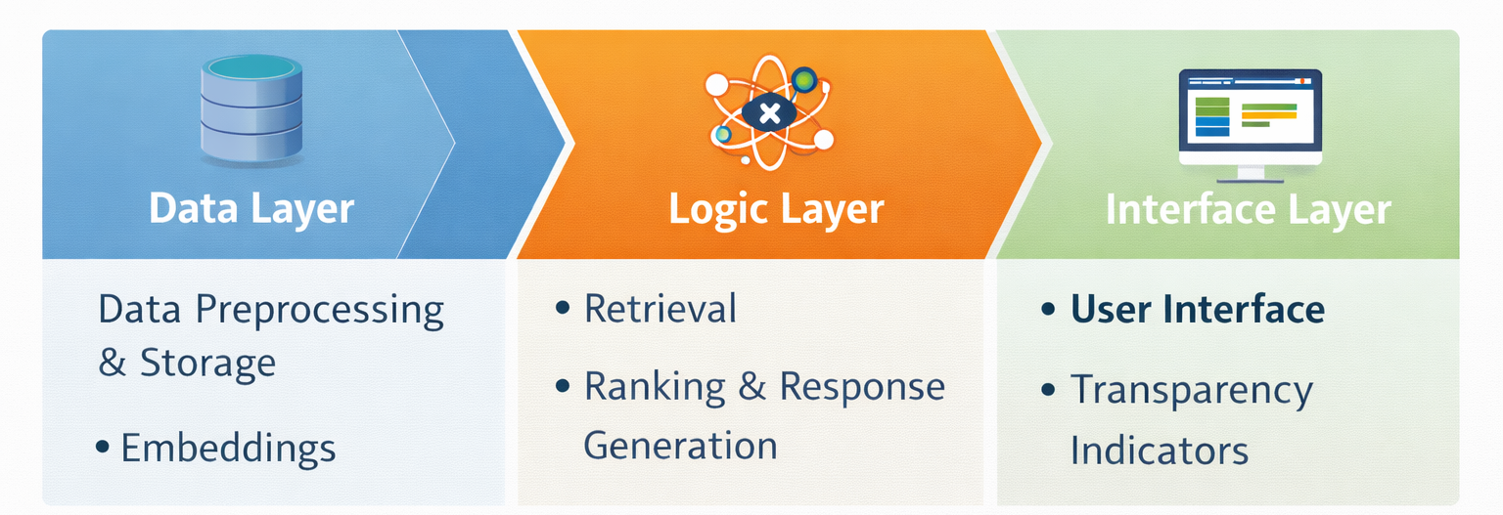

Figure 3. System Architecture Diagram.

2.3 Task Assignment/Teamwork Management.
The assignment of tasks was done with consideration of the technical background and level of confidence of the team members. I did not just focus on the efficient distribution of work, but on the fact that everybody felt that they owned what they were supposed to do.

To facilitate cooperation, I established a joint version control repository and designed the project in such a way that one could develop a massive component separately. In tandem with this, I had implemented common documentation guidelines so that decisions, dependencies and assumptions could be seen by everyone on the team.

3.4 Recapturing and Reviewing Progress.
In the course of the project, I have followed a progressive system of tracking the progress. Once work had been submitted after each development phase, I went over to the high level to ensure that the work was in line with what was agreed and at what point in time. Constructive suggestions were given on how the integration was ready and generally coherent, not technical.

Another tactic that I used was promotive reflection in review meetings, where the team members would evaluate what was functioning well and what should be changed.

2.5 Integration and System Testing Co-ordination.
Later on in the project, my interest in managing system integration developed. I collaborated closely with the QA position to try proving that the various components were to operate harmoniously as planned and that the system worked as per the transparency requirements of the project. Instead of undertaking the technical testing, I would organise testing and make sure that the products produced were examined against the specifications of the expected product.

2.6 Communication and Conflict Management.
Communication was one of the key points in my leadership position, in general, and especially in my team, considering its interdisciplinary nature. There were also differences in priorities, which sometimes resulted in disagreements, particularly with the struggle between speed of development and quality and ethics.

Whenever these conflicts occurred, I ensured that I organised structured discussions whose goals were centred on common objectives as opposed to individual preferences. With the help of a positive mindset toward evidence-based thinking and a respectful discussion, I managed to lead the team to the solutions that would be in line with the values of the project.

2.7 Documentation and Reporting
I kept records of the activities of the project, decisions and updates regarding the progress of the project throughout the internship. This involved meeting briefings, milestone reports and integration notes, which were all part of transparency and accountability.

Progress summaries were provided regularly both to the team and to the supervisor so that an assessment could be made on what was accomplished and aspects had to be further addressed. This documentation also aided academic reporting as well as made the development of the project traceable and able to be effectively evaluated. Focusing on regular documentation, I gained more organisational skills and supported the significance of proper records-keeping in practice.

Contribution

3.1 Leadership and Strategic Direction
As a central element in enhancing the customer experience model, management needs to address the principal issues. Being the Team Leader, I was able to play the most significant role as I clearly directed and structured the project. The primary task I was supposed to address was to make sure that the team operated in accordance with the unified vision and, at the same time, remained focused on the goals and objectives of the project relating to transparency, accuracy, and ethical AI design. I interpreted top tiers project objectives into measurable and achievable tasks by setting expectations and success objectives for all roles.
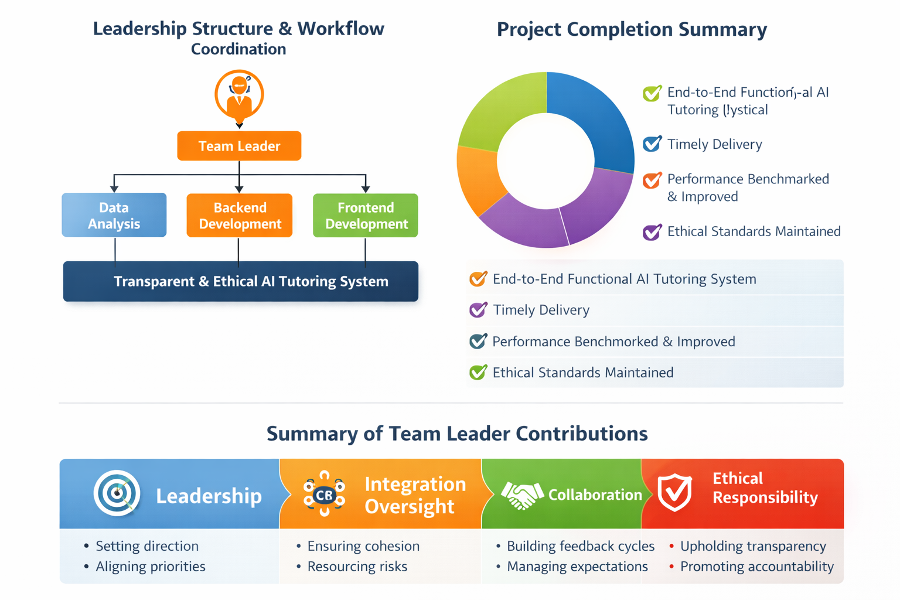
Figure 4. Workflow Coordination Diagram/ Leadership Structure.

3.2 Technical Supervision and Integration Support.
Though I did not do it as the major developer of the project, I was actively involved in overseeing the technical integration, as well as assisting in keeping the system components aligned. My input was aimed at making sure that personal developments were summed up into an intricate and operational system.

Close work with back-end and data roles ensured I engaged in reviewing design decisions at a conceptual level, especially where design decisions may affect transparency or system behaviour. My responsibility as well was to ensure different interactions of modules, and in this regard, interfaces between components were well defined and implemented uniformly.

3.3 Main Principles of Globalisation.
One of the main elements of my input was the communication management with the members of the internal team and the project supervisor. I also made sure that the progress updates were presented systematically and frequently so that it is possible to integrated the feedback.

I was also proactive in enabling the exchange of information between testing results and the development response, so that problems, which were raised as a result of evaluation, would be resolved as soon as possible.

3.4 Quality and Ethical Oversight.
Other than the aspect of delivery and coordination, I was in charge of maintaining the ethical principles within the project. I also made sure that the choice in designing and development could support the project in terms of its transparency and accountability concerning the use of AI. This would in practice require the management of the presentation of system responses to users and the consistent provision of confidence indicators, as well as transparency labels.

3.5 Outcome and Impact
Due to systematic management, constant observation, and moral management, the project was accomplished successfully and on time. The last result was a viable prototype which showed the technical consistency and responsible design. The system fulfilled its desired goals, such as the ability to present responses transparently, the successful implementation of the system components, and the improvement of performance that could be measured with every new iteration of the system.
Figure 5. Project Completion Summary Chart.

3.6 Summary of Contribution
To conclude, strategic leadership, integration supervision and ethical responsibility characterised my involvement in the project. I gave guidance, coordinated and managed to ensure that the efforts of individuals were in line with the overall objectives of the project. In this position, I managed to prove skills in leading a technically demanding project and adhering to professional standards and reflective consciousness.

Figure 6. Summary of Team Leader Contributions Diagram.

Reflection

4.1 Application of Driscoll’s Model
To critically reflect on my experience as a Team Leader, I applied Driscoll’s Model of Reflection, which structures reflection around three key questions: What?, So What?, and Now What?. I selected this model because it provides a clear and practical framework for evaluating professional experience, particularly in leadership and applied computing contexts.

4.1.1 What?

During the internship, I acted as the Team Leader of an interdisciplinary group responsible for developing a RAG-based AI tutoring system. My role involved planning milestones, defining workflows, and coordinating activities across frontend, backend, data, and quality assurance functions. At the beginning of the project, I found it challenging to balance technical involvement with leadership responsibilities.

4.1.2 So What?

Reflecting on these experiences helped me understand the importance of adaptive leadership and trust within a technical team. I realised that effective leadership is not about maintaining control, but about enabling others to take ownership of their responsibilities. When I shifted from direct involvement to guidance and support, I observed noticeable improvements in both productivity and team morale.

4.1.3 Now What?

This reflection has directly informed my plans for future development. I recognise the need to continue strengthening my leadership capabilities through both formal learning and practical experience. In particular, I aim to develop structured delegation strategies and clearer accountability frameworks in future projects. I also intend to enhance my technical leadership knowledge by learning more about scalable AI deployment practices, such as MLOps, to better support system-level decision-making.

4.2 Challenges and Resolutions

4.2.1 Challenge 1: Balancing Technical and Managerial Responsibilities
One of the main challenges I encountered was managing both technical oversight and organisational responsibilities simultaneously. Attempting to control both aspects initially led to fatigue and delayed communication.

Resolution: I introduced clearer task ownership by defining responsibilities explicitly and relying on asynchronous updates rather than constant direct involvement. This allowed me to focus more effectively on leadership and coordination.

4.2.2 Challenge 2: Team Communication Barriers
Early stages of the project revealed inconsistencies caused by limited alignment between team members and system components.

Resolution: I implemented regular review sessions, shared documentation practices, and structured update formats to improve transparency and coordination across roles.

4.2.3 Challenge 3: Ethical and Performance Trade-offs
At times, there was pressure to prioritise performance improvements over transparency measures, particularly around confidence reporting.

Resolution: I consistently reinforced ethical requirements by ensuring that transparency indicators remained integral to the system, even where this introduced additional complexity.

4.3 Reflection Summary
This internship significantly reshaped my understanding of leadership within a technical project environment. I learned that effective leadership is not defined by authority, but by the ability to guide, structure, and support others while maintaining accountability and ethical awareness.

Through reflective practice, I developed from a technically focused contributor into a more balanced and reflective leader capable of managing complexity through communication, empathy, and strategic thinking. This experience has provided a strong foundation for my future professional development in leadership-oriented technical roles.

Personal Benefits

5.1 Skills in Strategic Management and Leadership.
This internship made my leadership and strategic management skills significantly improve. Instead of a coordination exercise, I was able to learn how to lead a group through the darkness and still be able to focus on quality and good morals. I was more assured of setting achievable goals, tracking the achievements of set targets, and changes of plans when setbacks were experienced.
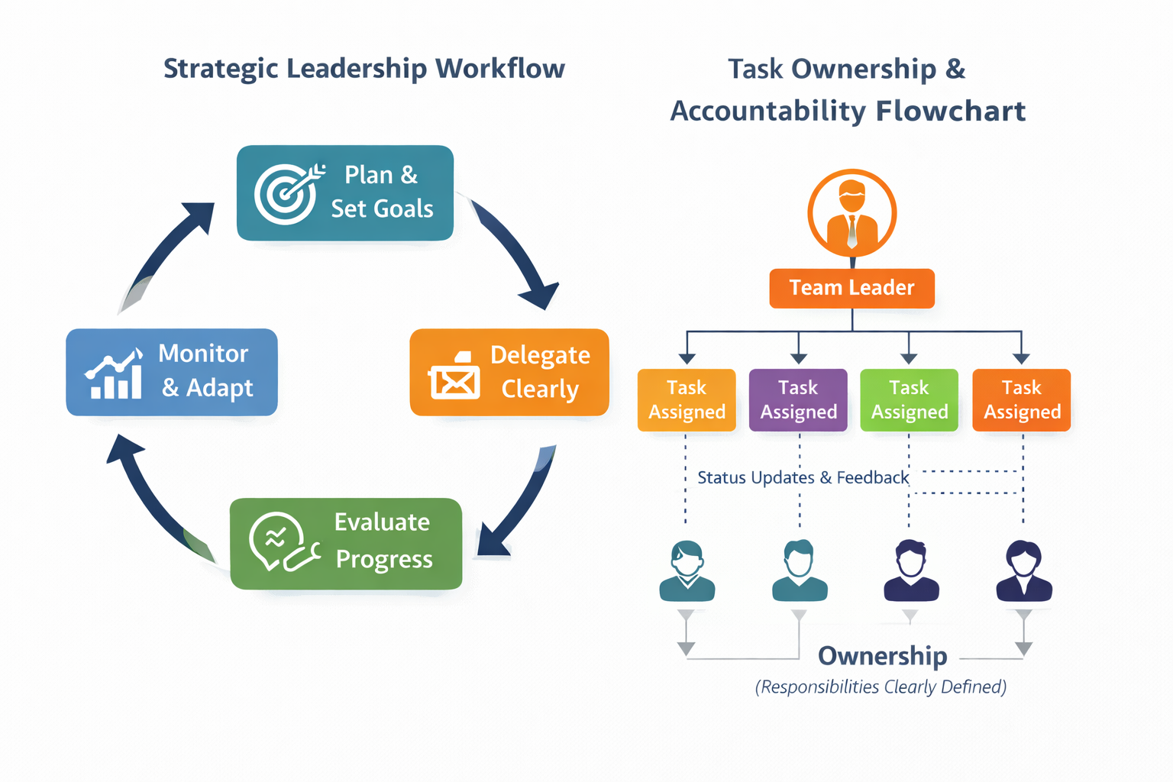
Figure 7. Workflow Diagram Strategy Leadership.

5.2 The technical, analytical development.
Even though the main operation I did was leadership-oriented, I also attained a better technical background as I managed system integration and assisted with troubleshooting. This necessitated that I interact with technical concepts at a system level other than at an implementation level.

I have gained a better insight into the way a RAG-based system is organised, the communication between backend services and the user-facing parts and the impact the performance has on design choices. I also learnt the collaborative practices of development, such as version control, modular design and coordinated testing workflow..

5.3 Knowledge in Communication and Interpersonal Skills.
As a team leader of a multidisciplinary team, clear, empathetic communication was needed regularly. During the internship process, I gained confidence in helping to run the discussions, representing issues, and eliminating differences in working styles. I also mastered the techniques of active listening, turning feedback into productive action, and giving advice, but not demotivating to initiate action.

5.4 Ethical and Professional Awareness
The internship was an important boost in my understanding of the ethical responsibility in AI development. I understood better that technical choices have an impact on trust, impartiality and user comprehension. I made sure that ethical requirements, including transparency, accountability, and responsible use of data, were not detailed descriptions but fundamental design requirements.

5.5 Personal Development
At the individual level, the internship boosted my self-confidence, resilience, and self-awareness. I was educated on how to deal with pressure, prioritise competing interests, and be unbiased in the process of decision-making. I also learned the importance of rewarding gains and commending minor successes, which contributed to maintaining the motivation level in the team.

5.6 Summary
Altogether, the internship has become a very drastic experience that has reinforced my personal and professional abilities. Not only did I come out with a better understanding of leadership and technical awareness, but I also gained a better idea of ethical responsibility and conduct in the projects led by artificial intelligence.

Professional Values

6.1 Accountability
My style as Team Leader involved accountability. I made myself accountable for the team's successes and the challenges to ensure that this was tackled positively, as opposed to blaming individuals. I kept a clean record of decisions, progress and outcomes by exercising good documentation and version control tradition. In the instances that problems arose, I was very concerned with finding solutions to them together, and this emphasised a culture of shared and collective responsibility.
Figure 8. Task Ownership and Accountability Flowchart.

6.2 Integrity
Integrity was reflected in my communication of progress and risk when communicating it to the team and to the supervisor. I did not create an impression of preparedness or hiding difficulties, even when schedules were at stake. Telling the truth about constraints and compromises, especially between speed and quality, I was able to establish a level of trust within the group. This strategy also meant that the end system would have been a manifestation of the honest work and moral way of doing, and not a mere high-flying success.

6.3 Respect and Collaboration
The basis of collaboration in the teamwork was respect. I promoted free dialogue and appreciated suggestions irrespective of position and seniority. This participative model established a space where the members of the team were able to express ideas and voice concerns without hesitation. Through the concept of publicly appreciated individual contribution, I actively ensured that people respected and reinforced the bond among the members of the team.

6.4 Ethical Leadership in AI
My leadership was not only restricted to technical coordination but also to ethical control. My responsibility was to check that data usage, system behaviour, and output to the end users met trustworthy AI concepts. This also involved scrutinising any ethical data source and making sure that transparency indicators were being made evident and that any results generated by AI were not being misinterpreted as actual information.

6.5 Professional Value Reflection
This internship helped me to understand the concept of professionalism in computing. I also received what professional competence should be followed by the ethical judgment, integrity and accountability. My leadership approach also changed and became more focused on delivery, but also trust, responsibility, and respect. I have now viewed professional values as part of successful leadership and necessary to realise sustainable and ethical results of AI's undertakings.

7. References
- Arrieta, A.B., Díaz-Rodríguez, N., Del Ser, J., Bennetot, A., Tabik, S., Barbado, A., García, S., Gil-López, S., Molina, D., Benjamins, R., Chatila, R. and Herrera, F. (2020) ‘Explainable Artificial Intelligence (XAI): Concepts, taxonomies, opportunities and challenges’, Information Fusion, 58, pp. 82–115.
- British Computer Society (BCS) (2023) Code of Conduct for BCS Members. Available at: https://www.bcs.org/standards-and-guidelines/ethical-guidelines
- Driscoll, J. (2007). Practising Clinical Supervision: A Reflective Approach for Healthcare Professionals. 2nd edn. Edinburgh: Elsevier.
- Edmondson, A. (2018). The Fearless Organisation: Creating Psychological Safety in the Workplace. Hoboken: Wiley.
- Floridi, L., Cowls, J., Beltrametti, M., Chatila, R., Chazerand, P., Dignum, V., Luetge, C., Madelin, R., Pagallo, U., Rossi, F., Schafer, B., Valcke, P. and Vayena, E. (2018) ‘AI4People—An ethical framework for a good AI society’, Minds and Machines, 28(4), pp. 689–707.
- Higham, N. and Government Office for Science (2019) Understanding Artificial Intelligence Ethics and Safety. London: UK Government.
- Kerzner, H. (2017). Project Management: A Systems Approach to Planning, Scheduling, and Controlling. 12th edn. Hoboken: Wiley.
- Schön, D.A. (1983). The Reflective Practitioner: How Professionals Think in Action. New York: Basic Books.
- Scrum.org (2020.) What is Agile?. Available at: https://www.scrum.org/resources/what-is-agile
- University of Teesside (2024) CIS4006 Advanced Practice – Individual Coursework Assessment Guidelines. Middlesbrough: School of Computing, Engineering and Digital Technologies.

